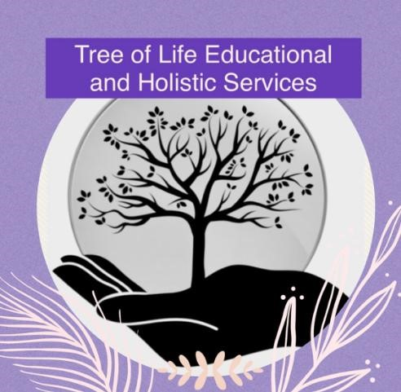

Managing Allegations- Child

Original: April 2024
Every organisation that works with children must have procedures about how to respond to allegations of abuse made against a child and concerns that a child or young person may pose a risk to others.
The information in this policy will help you to:
- ensure children who have been impacted by the abuse are given appropriate support
- provide the child or young person who is alleged to have displayed abusive behaviour with the appropriate help
- manage any risks to children’s safety and take appropriate steps to keep all children safe
- make sure your organisation's response to any allegations is proportionate, fair and consistent.
Types of Allegations
There are different ways that a child or young person may be abusive towards others, and they might not realise they are doing so:
- bullying or cyberbullying
- emotional abuse
- online abuse
- physical abuse
- sexting
- sexual abuse.
When a child abuses another child, it is sometimes called 'peer-on-peer' or 'child-on-child' abuse. Peer-on-peer abuse refers to abuse that takes place between children of a similar age, whereas child-on-child refers to abuse between children of any age. Sometimes children might also display abusive behaviour towards adults.
Identifying Concerns
There are a range of ways concerns might be raised.
- A child or adult might make a direct allegation of abuse by a child or young person.
- A child or adult might tell you they're uncomfortable with a child or young person's behaviour. They may not realise the behaviour is abusive.
- A member of staff or volunteer might observe behaviour that gives cause for concern and make a report following your organisation’s safeguarding procedures.
- Your organisation may be informed that a child or young person is the subject of an investigation.
- A child or young person might tell you they have harmed someone else or are at risk of doing so.

Responding to Concerns
When responding to an allegation of abuse made against a child, it's important to consider the needs of everyone involved.
Talking to a child who tells you they have behaved abusively
Sometimes a child may tell you directly that they have behaved abusively towards someone else.
You should talk to them calmly and remember that they need support.
- Reassure the child that they've done the right thing by telling you about it.
- Listen carefully to the child and let them tell their whole story. Don't try to investigate or quiz the child, but make sure you understand what they're saying.
- Use non-judgmental language.
- Tell them that you now must do what you can to keep them, and the other children involved safe.
- Never promise to keep what a child tells you a secret. Explain that you will need to speak to other people who can help.
- Reassure the child that they can get help to change their behaviour and move forward with their life
- You may want to suggest the child contacts Childline for support.

Talking to a child about allegations against them
If allegations have been made against a child you should speak to your nominated child protection lead, who can advise you on the best way to proceed. If you talk to the child about the allegations before taking advice, it may make the situation worse.
Responding to incidents
Sometimes you might see a child behaving inappropriately and decide to talk to them about this immediately, to manage the behaviour. Remember that they may not realise their behaviour is unacceptable. Talk to them calmly and explain why their behaviour is unsuitable and what they can do to improve it.
Keeping records
It's important to keep accurate and detailed notes on any concerns you have about a child’s behaviour. You should share this record with the person responsible for the supervision or pastoral care of the child and your nominated child protection lead.
Include:
- the child's details (name, age)
- the date and time of the incident
- what was happening before the incident took place
- what the child said or did that gave you cause for concern (write down their exact words if possible)
- whether the behaviour appeared spontaneous or premeditated.
Deciding if a concern is a child protection issue
If a child or young person displays inappropriate or harmful behaviour, you should inform TOL safeguarding lead
The safeguarding lead with support from senior leadership should decide what action to take.
When an allegation is a child protection concern
An allegation becomes a child protection concern when:
- the behaviour involves sexual assault or physical assault
- the child who has experienced the abusive behaviour has suffered significant harm
- the behaviour forms part of a pattern of concerning behaviour by the child or young person who is being abusive
- the child carrying out the abuse is displaying sexualised behaviour
- you are concerned that the child carrying out the abuse may be doing so because they have experienced abuse themselves.
It is also a child protection concern when there's a significant difference of power between the child who is displaying abusive behaviour and the person being abused, for example when:
- there's an age difference of more than two years
- there's a significant difference in terms of size or level of ability
- the child displaying abusive behaviour holds a position of power (such as being a helper, volunteer or informal leader)
- the child being abused is significantly more vulnerable than the other child or young person.
If a young person in your organisation has been involved in sexting (sharing nude images), there are extra factors to consider.
Reporting concerns
If you think a child is in immediate danger, contact the police on 999. If you're worried about a child but they are not in immediate danger, you should share your concerns.
- Follow TOL organisational safeguarding policies and procedures.
- Report to the police as appropriate (for example, if an allegation of physical or sexual assault or a sexual offence is made). This should happen alongside a making a referral to children’s social care, following local authority guidelines.
- Contact the NSPCC Helpline - Our child protection specialists will talk through your concerns with you and give you expert advice.
- Contact the Report Abuse in Education Helpline
- Contact your local child protection services.
Multi-agency working
The safeguarding lead will, if required, share all relevant information with multi-agency partners.
Taking action to keep all children and young people safe
Depending on the nature of the allegation or concern, you may need to take action to protect and support children who have experienced child-on-child or peer-on-peer abuse.
Sanctions
TOL have a behaviour policy that highlights what sanctions will apply to anybody who displays inappropriate behaviour. These should be fair and proportionate to the behaviour being displayed and will be agreed by senior leadership.
Emotional support
If child-on-child or peer-on-peer abuse has taken place at TOL, it can have an emotional impact on everyone.
Make sure children, young people and adults have access to the emotional support they need and know who they can talk to if they are worried about anything. TOL have specialist therapist available for any child who may require additional emotional support.
Risk assessment
TOL risk assesses all situations, this is documented. (see risk assessment policy).
Telling parents and carers about an allegation made against their child
A child's parents or carers should be told what has happened, as long as it doesn't increase the risk to the child. The senior leadership team will hold this conversation.
It's important for parents or carers and children to talk about what's happened and begin to come to terms with it as a family.
When talking to parents or carers, remember that the news their child has behaved abusively may be a shock. Reassure them that support is available to help their child change their behaviour and move forward.
Support for parents and carers
TOL will also make sure that the parents and carers are offered appropriate support. This might include:
- therapeutic support to help them come to terms with what’s happened
- family therapy to help the whole family move forward
- help to reinforce messages about positive behaviour and support their child to change their behaviour.
Guidance on managing allegations made against a child
Statutory guidance across the UK highlights the responsibility of those in the education, community and care sectors to safeguard children from all forms of abuse and neglect. This includes making sure that all children who have experienced and displayed abusive behaviour are supported appropriately.

